January 1, 2024

Re: Indirect Cost Rate for ABFM and ABFM Foundation Grants and Contracts

To Whom it May Concern:

Please allow this letter to confirm that the maximum allowable indirect cost rate that can be built into budgets for grants and contracts issued by the American Board of Family Medicine or the ABFM Foundation is 10%.

When a budget is not required and an award is issued in response to a request for funding by either the ABFM or the ABFM Foundation, the award amount is often stated as a maximum and no indirect costs are permitted above the maximum award.

Sincerely,

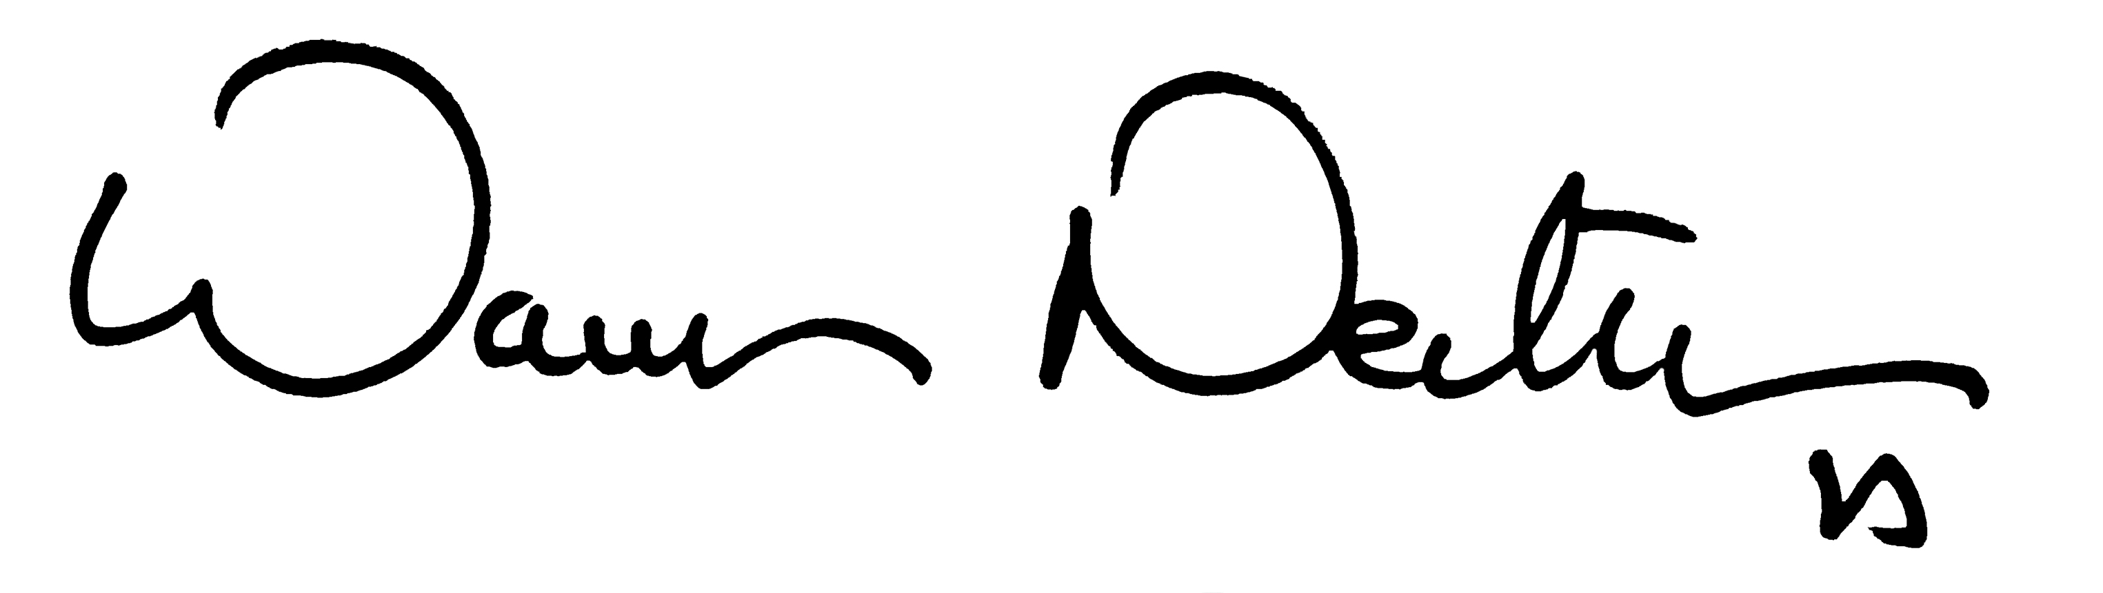

Warren P. Newton, M.D., MPH
President and Chief Executive Officer

